A.implementation of stack using array.
#include<stdio.h>
#define MAX 5 // Maximum size of stack

int stack[MAX];
int top = -1;

// Push operation
void push() {
int value;
if (top == MAX - 1) {
printf("Stack Overflow! Cannot push element.\n");
} else {
printf("Enter element to push: ");
scanf("%d", &value);
top++;
stack[top] = value;
printf("%d pushed into stack.\n", value);
}
}

// Pop operation
void pop() {
if (top == -1) {
printf("Stack Underflow! Stack is empty.\n");
} else {
printf("%d popped from stack.\n", stack[top]);
top--;
}
}

// Display operation
void display() {
if (top == -1) {
printf("Stack is empty.\n");
} else {
printf("Stack elements are:\n");
for (int i = top; i >= 0; i--) {
printf("%d\n", stack[i]);
}
}
}

// Main function
int main() {
int choice;

while (1) {
printf("\n--- STACK MENU ---\n");
printf("1. Push\n");
printf("2. Pop\n");
printf("3. Display\n");
printf("4. Exit\n");
printf("Enter your choice: ");
scanf("%d", &choice);

switch (choice) {
case 1:
push();
break;
case 2:
pop();
break;
case 3:
display();
break;
case 4:
exit(0);
default:
printf("Invalid choice! Try again.\n");
}
}
default:
printf("Invalid choice! Try again.\n");
}
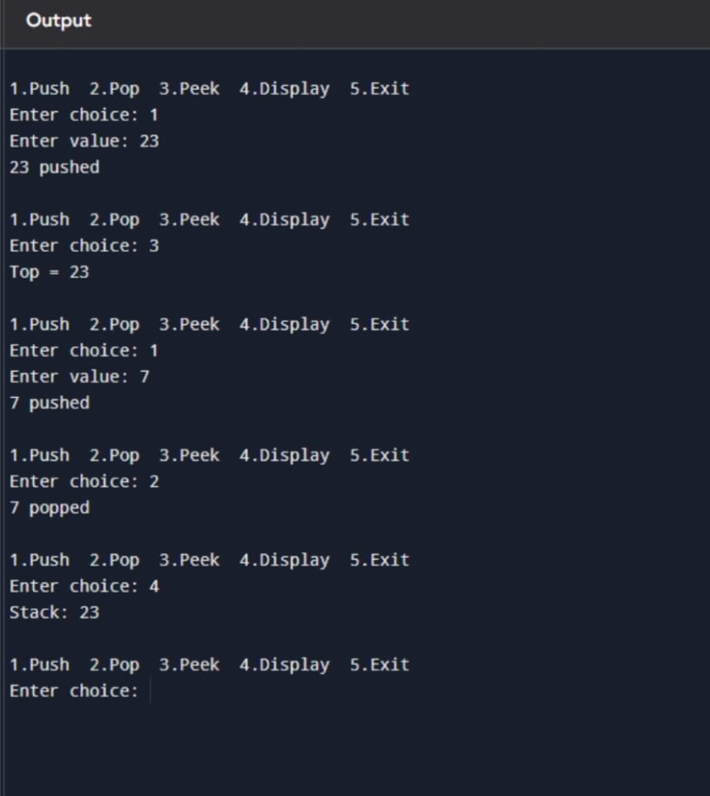

B. A compiler front-end receives arithmetic expressions in infix form entered by programmers. To simplify expression evaluation, the compiler internally converts expressions into postfix form. Write a program to convert a given infix expression into postfix expression using stack.

#include <stdio.h>
#include <ctype.h>
#include <string.h>

#define MAX 100

char stack[MAX];
int top = -1;

// Push function
void push(char x) {
stack[++top] = x;
}

// Pop function
char pop() {
if (top == -1)
return -1;
else
return stack[top--];
}

// Check precedence
int precedence(char x) {
if (x == '+' || x == '-')
return 1;
if (x == '*' || x == '/')
return 2;
if (x == '^')
return 3;
return 0;
}

int main() {
char infix[MAX], postfix[MAX];
int i, j = 0;

printf("Enter Infix Expression: ");
scanf("%s", infix);

for (i = 0; i < strlen(infix); i++) {

// If operand, add to postfix
if (isalnum(infix[i])) {
postfix[j++] = infix[i];
}

// If '(', push to stack
else if (infix[i] == '(') {
push(infix[i]);
}

// If ')', pop until '('
else if (infix[i] == ')') {
while (stack[top] != '(') {
postfix[j++] = pop();
}
pop(); // Remove '('
}

// If operator
else {
while (top != -1 &&
precedence(stack[top]) >= precedence(infix[i])) {
postfix[j++] = pop();
}
push(infix[i]);
}
}

// Pop remaining operators
while (top != -1) {
postfix[j++] = pop();
}

postfix[j] = '\0';

printf("Postfix Expression: %s\n", postfix);

return 0;
}
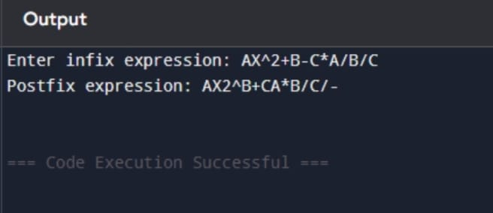

C. An Integrated Development Environment (IDE) needs to validate and convert arithmetic expressions written by students. Write a program to convert an infix expression to postfix and display an error message if parentheses are mismatched.

#include <stdio.h>
#include <ctype.h>
#include <string.h>

#define MAX 100

char stack[MAX];
int top = -1;

// Push
void push(char x) {
stack[++top] = x;
}

// Pop
char pop() {
if (top == -1)
return -1;
return stack[top--];
}

// Precedence function
int precedence(char op) {
if (op == '+' || op == '-')
return 1;
if (op == '*' || op == '/')
return 2;
if (op == '^')
return 3;
return 0;
}

int main() {
char infix[MAX], postfix[MAX];
int i, j = 0;
int error = 0;

printf("Enter Infix Expression: ");
scanf("%s", infix);

for (i = 0; i < strlen(infix); i++) {

// If operand, add to postfix
if (isalnum(infix[i])) {
postfix[j++] = infix[i];
}

// If '(' push to stack
else if (infix[i] == '(') {
push(infix[i]);
}

// If ')'
else if (infix[i] == ')') {
while (top != -1 && stack[top] != '(') {
postfix[j++] = pop();
}

if (top == -1) { // No matching '('
error = 1;
break;
}
pop(); // Remove '('
}

// If operator
else {
while (top != -1 &&
precedence(stack[top]) >= precedence(infix[i])) {
postfix[j++] = pop();
}
push(infix[i]);
}
}

// Check remaining stack
while (top != -1) {
if (stack[top] == '(') {
error = 1;
break;
}
postfix[j++] = pop();
}

postfix[j] = '\0';

if (error)
printf("Error: Mismatched Parentheses!\n");
else
printf("Postfix Expression: %s\n", postfix);

return 0;
}
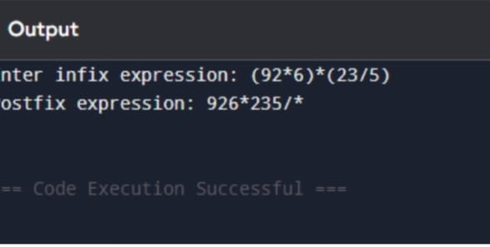

D. A calculator application internally stores arithmetic expressions in postfix format for faster evaluation. Write a program to evaluate a given postfix expression using a stack.

#include <stdio.h>
#include <ctype.h>
#include <math.h>

#define MAX 100

int stack[MAX];
int top = -1;

// Push function
void push(int value) {
stack[++top] = value;
}

// Pop function
int pop() {
return stack[top--];
}

int main() {
char postfix[MAX];
int i;
int op1, op2, result;

printf("Enter Postfix Expression: ");
scanf("%s", postfix);

for (i = 0; postfix[i] != '\0'; i++) {

// If operand, push into stack
if (isdigit(postfix[i])) {
push(postfix[i] - '0'); // Convert char to int
}

// If operator
else {
op2 = pop();
op1 = pop();

switch (postfix[i]) {
case '+': result = op1 + op2; break;
case '-': result = op1 - op2; break;
case '*': result = op1 * op2; break;
case '/': result = op1 / op2; break;
case '^': result = pow(op1, op2); break;
default:
printf("Invalid Operator!\n");
return 0;
}

push(result);
}
}

printf("Result of Postfix Expression: %d\n", stack[top]);

return 0;
}
